20.8.2018

* A05

21.8.2018

* A01
* A02
* A03
* A04

22.8.2018



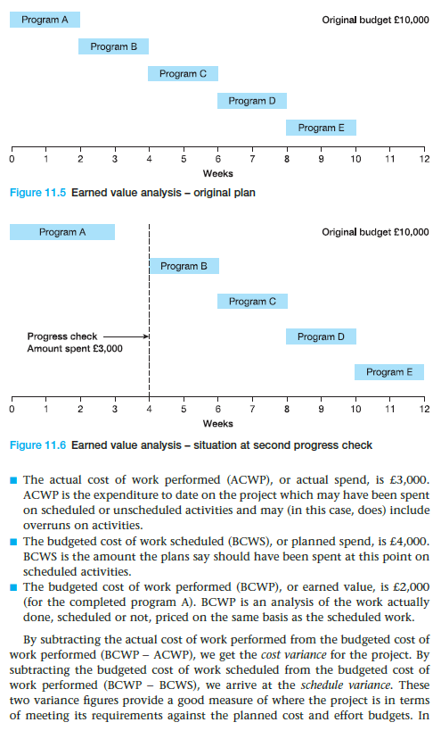

As a <type of user>, I want <some goal> so that <some reason>